_____________________________________________________________
Turkish School Libraries: New Roles, But How?
Ayse Yuksel-Durukan
Robert College Library Media Center
Kurucesme cad. 87 Arnavutkoy 34345
Istanbul Turkey
E-mail: ayuksel@robcol.k12.tr
__________________________________________________________________________
Abstract
This paper focuses on school libraries in Turkey. It is a General outlook on k-12 education and how the community perceives the School Library. A short history of school libraries and the problems they face will be pointed. Is a school library part of the education or is it a supplementary issue? How do librarians view the issue? How does the Ministry of Education sees the centers?
The current trends in Turkish school librarianship: what is the near future of the library media centers and how will the learning-commons strategy affect them?
The Turkish government is about to release a new version of Intellectual Property Rights. School librarians and all educators should stress the importance and the necessary practices in order to go hand in hand with the global world.
Key words: Turkey, School Libraries, School Librarians, Reading.

Turkey is a country that lies at the crossroads of Asia and Europe and is surrounded by Black Sea and the Mediterranean. The country has a population of 74,724.269 (The results of Address Based Population System) with a gross domestic product per capita $ 10,973 (GDP per Capita). There are 65,800,000 mobile subscribers (Cep Telefonu). Internet users are about 35,000,000 and facebook users are indicated as 30,666,980 ( Facebook Statistics by Country). However some of the facebook accounts may be considered as fake. According to the report of World Economic Fund Turkey is the 124th among the 135 countries when the subject is gender gap (The Global Gender Report). In 2012 there were 43,190 titles of books published of which 1314 are e-books. The book publishing industry is a $1,500,000,000 market and 30% of this are translations (2011 Turkiye Kitap Pazari) from other languages. Turkey is improving in some economic areas but social conditions are slow to align.
Reading Landscape
The ministry of Tourism in conjunction with the Libraries and Publishers section with the leadership of Onur Bilge Kula and Ankara University published the research results on the reading habits in 2011. This survey was given in 26 cities with 6212 respondents, consisting of half women and half men. 30% of the people were students and 27% housewives. I have chosen 4 pages from that book to give insights on reading and libraries. Only one out of four has reading habits in Turkey (Kula 60).
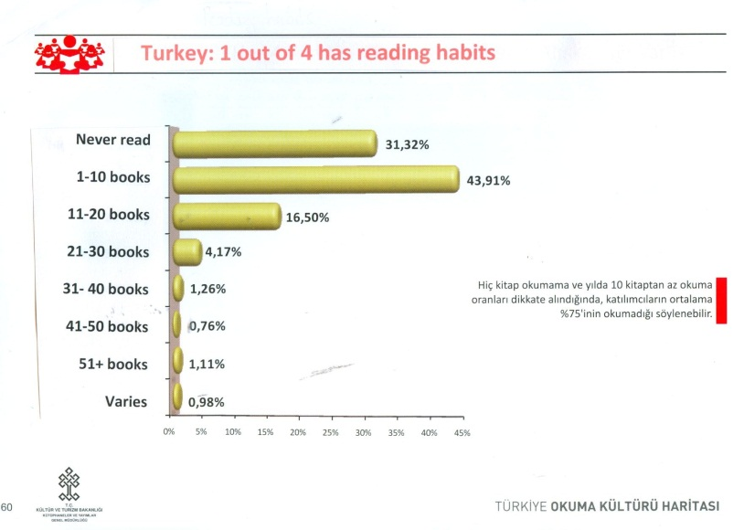
The reasons for not reading were listed as such: with 60.83% saying no time to read and 18.97% indicating they would prefer watching TV instead of reading (Kula 66).
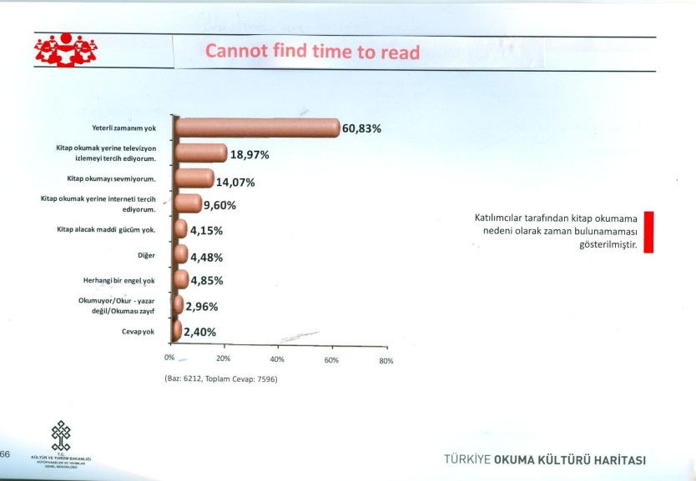
Another critical question ‘how did you earn your reading habits’ was replied as by the respondents as their own initiative by 74.72%. Teacher impact was 15.76% which was followed by parents by 14.55%. Both of these influences are quite low and librarian impact is not even considered (Kula 67). The last slide I would like to draw attention is answer to the question ‘why don’t you feel the need for a public library?’ There are 1112 public libraries in Turkey. 47.4% said that they did not have that habit. 17.7% indicated that they do not enjoy reading books or magazines. %14 thought that their own library satisfied them whereas 13.2% said they read and looked up information from the Internet. 10.2% said that they did not like libraries (Kula 203).
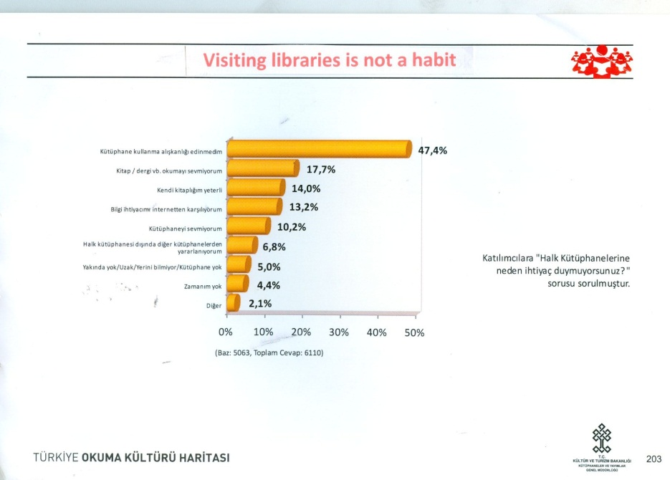
When the reading the reading habits are so low, the school librarians and the teachers have a long way to go in promoting the subject. If we look at the population statistics of ages between 5 to 19 there are about 19,000,000 whereas this population adds up to 25,000,000 when 0 to 19 years are considered. These numbers indicate a vast ratio. When we look at the schooling map (k-12) of the country there are 60,165 buildings; 4,647 of which are preschools, 32,108 are primary schools and 9,672 are high schools (Education Statistics). Pre-schooling is new. The country needs more schools than ever.
The Ministry of Education gives the total number of school libraries as 26.219 with 19.136 as public schools, 5.763 as private courses, and 1.320 private schools. The total number of employees working at school libraries is 3.189 but only 450 of these are Library Science graduates; 1.372 of them are high school, 916 are other college or university graduates, with 342 secondary and 109 of them are primary school graduates (Education Statistics). Turkey does not have sufficient school libraries. Even if a school has a library that does not mean they have a trained school librarian.
Programme for International Student Assessment publishes participating countries reading scores of ages fifteen. Among the 34 OECD countries Turkey ranks as 32nd (OECD PISA ).
The concerned school librarians are a small group in Turkey. The school librarians first met in 2002 and continued since then. The first School Librarians’ Conference was held at Robert College in Istanbul in 2003 with 80 participants; the second at Uskudar Academy, in Istanbul 2009 with 123 and the third in Ankara Bilkent High School in 2010 with 60 participants. These activities led to a revival of school librarianship and created an awareness in the k-12 education influencing other school librarians and library and information students.
School Librarians
My survey with school librarians in 2012 was done with 60 participants through email. Those who were Library & Information Science graduates were %47, teachers who acted as librarians were %4 and others were %14. Almost all of the respondents were from private schools, 95%. The private schools in Turkey are the forerunners of school libraries and librarians. Most private schools are keen to go through the accreditation process whether these be ECIS, NYSAIS, NEASC, or CIS. Also since 1994 thirty five schools are offering one or more of the three IB programmes. All these institutions and organizations demand for an appropriate collection of library or multimedia resources and/or a librarian to support the programmes. Therefore private schools who are on accreditation or IB programmes are sensitive to the issue of having a school library and a trained school librarian.
The small group of school librarians and teachers that I surveyed consisted of 86% women and 11% men. They worked mostly with high school students, 80%, and 55% primary, and preschool 29%. The number of students they dealt with was 47% with a student population of 500 to 1000. Over 1000 were 28%. Students less than 500 were 21%.
Education of School Librarians
Only 58% Library Science graduates had received some kind of school library related subjects. There are 16 universities which offer Library and Information Science education in Turkey. Only Hacettepe University, Ankara offers school library related subjects in their curriculum. School librarians who answered the survey, 67% had teaching certificate, whereas 26% did not. What describes you most was replied as such: 47% saw themselves as ‘teacher librarian,’ 44% as ‘librarian,’ 4% as ‘clerk,’ and 2% as ‘tech coordinator.’ All school librarians are concerned about education and teaching.
The subjects they taught at their libraries were:
- Library orientation -92%
- Reading hour - 69%
- Research & academic honesty - 69%
- Information literacy –59%
- Information skills - 49%
- Internet literacy - 45%
- Story time - 41%
- Media literacy - 40%
- Digital citizenship - 2%
They attend meetings with teachers, 53%; but a large group is denied that, 44%. The school librarians are not expected to contribute to the curriculum 58%, they are not seen as partner for the education. Only 38% said that they act as curriculum instructors. 56% has a separate budget but only 30% are in charge of their budgets. 70% of school librarians have a written policy. In most schools the administration does not view the school library and the trained librarian seriously. That is why only 53% attend meetings with the faculty and this is mostly the result of the librarians’ efforts.
Facilities in School Libraries
80% have Internet access in their school libraries. 76% and 73% have areas for large groups and small groups. Their collection consists of mostly of print books, the numbers are in between 41, 000 to 6,000 books. Copyright date ranges from1995 to 2008. The multimedia:
- Periodicals – 98%
- DVDs - 87%
- Music CDs - 75%
- Databases - 58%
- Audio books - 36%
- E-books - 36%
- E-readers, tablets - 11%
The most popular cataloging software that is used is a Turkish brand Yordam, 47%. 19% use Follett, 7% use Milas, and 14% do their cataloging by hand like on an excel sheet or similar. Few of them make use of Web 2.0 tools like library blogs, Google documents, facebook and moodle: 37%.
On the survey 3 choices were given to describe their library: ‘Student centered learning area’ received the most votes with 68%; ‘reference center’ had 14% and ‘book station’ 12%. Three most important roles of the school librarian were written as ‘promoting books & reading’, ‘turning library usage into a habit’, ‘teaching research techniques,’ ‘making library more attractive’, ‘helping students finding relevant information’. The small group of school librarians in Turkey know that reading and reading habits has to improve. They are also aware that they can and should play an essential role in promoting reading.
But how does the Ministry of Education sees the school libraries/librarians? The ministry launched an electronic tablet project as of February 2012 called FATIH, Movement of Enhancing Opportunities and Improving Technology (FATIH Project). 10,000 tablets were given to 52 high schools in 17 cities chosen as pilot centers. If this experiment is successful all schools will have tablets and all information will be accessed through these tablets. If we consider the number of schools and the teachers FATIH can become a major project. No need to say the content of information has to be relevant and in harmony with the students’ age group. At the moment it is quite new and no information regarding the usage has been published. This project brought such an excitement that not all but many concerned partners think it will be the solution to all resources. The school library if it ever existed was seen as a supplementary unit. A trained librarian may not be hired in most cases. In the future therefore if this tablet project is successful there may not be a need for a learning center like a school library.
Copyright in Turkey
The first systematizing act of copyright in Turkey was first realized in 1857; but a more proper law became effective in 1910. The law remained in force until January 1st 1952 when the Law number 5846 on Intellectual and Artistic Works was issued. Turkey on the same date joined the Bern convention of Brussels of 1938 with the law numbered 5777. The law has been amended by the laws of 1983, 1995, 2001, 2004, 2006. In 1976 Turkey indicated the desire to join WIPO convention. Turkey has joined the Paris convention (1971) in 1995. In 2008 WIPO copyright treaty entered into force. In 2012 to ensure full compliance with the EU acquis the responsible committee has been holding numerous meetings. Since they are still working on revising, the final version of the law is not in action yet.
Pirating is an issue in the country but the government has been seriously addressing the problems. Not only the legislation of copyright has been positively amended in the last years, but also training courses for judges and the police have been launched. The police action against copyright infringements has been improved immensely.

References
Cep Telefonu Abone Sayisi. Ekonomik Ayrinti, 24 May 2012. Web. 1 Aug. 2012. <http://www.ekoayrinti.com/news_detail.php?id=99572>.
Culture Statistics, Libraries. Turkish Statistical Institute, 2012. Web. 1 Aug. 2012. <http://www.turkstat.gov.tr/VeriBilgi.do?alt_id=15>.
Education Statistics. Turkish Statistical Institute, 2012. Web. 1 Aug. 2012. <http://www.turkstat.gov.tr/PreTablo.do?alt_id=14>.
Facebook Statistics by Country. Socialbakers, 2012. Web. 1 Aug. 2012. <http://www.socialbakers.com/facebook-statistics/>.
FATIH Project. Ministry of Education, 2012. Web. 1 Sept. 2012. <http://fatihprojesi.meb.gov.tr/tr/english.php>.
GDP per Capita. The World Bank, 2012. Web. 1 Aug. 2012. <http://data.worldbank.org/indicator/NY.GDP.PCAP.CD>.
The Global Gender report. World Economic Fund, 2012. Web. 1 Nov. 2012. <http://www3.weforum.org/docs/WEF_GenderGap_Report_2012.pdf>.
Kula, Onur Bilge, comp. Turkiye Okuma Kulturu Haritasi. Ankara: T.C. Kultur ve Turizm Bakanligi, 2011. Print.
OECD Programme for International Student Assesment PISA. OECD, 2009. Web. 1 Aug. 2012. <http://www.oecd.org/pisa/pisaproducts/pisa2009/pisa2009resultswhatstudentsknowandcandostudentperformanceinreadingmathematicsandsciencevolumei.htm>.
The Results of Address Based Population System, 2011. Republic of Turkey, Turkish Statistical Institute, 31 Dec. 2011. Web. 1 Aug. 2012. <http://www.turkstat.gov.tr/PreHaberBultenleri.do?id=10736>.
2011 Turkiye Kitap Pazari Raporu = 2011 the Book Market Report of Turkey. Turkish Publishers Association, 2012. Web. 1 Aug. 2012. <http://www.turkyaybir.org.tr/komisyonlar/2011-turkiye-kitap-pazari-raporu/476>.

