Cnr Josiah Tongogara/Robert Mugabe Way
P.O. Box 640
Mutare, Zimbabwe
Telephone: 263-20-63141/63153
0772136934-5/0714900016-7/0735 054 661-2
Telfax: 020-66912
E-mail: principalmutarepolytechnic@gmail.com
www.mutarepolytechnic.ac.zw

6 December 2019

Attention:
The Provincial Education Directorate
Mutare

Report on the International School Library Month Held on 24 October 2019 at Hartzell Primary School.

This report covers what transpired the International School Library Month Held on 24 October 2019 at Hartzell Primary School in Mutasa District

Prepared by Mutare Polytechnic Librarian-Mrs P. Chibangwa
1.0. Introduction.
Improving communities is part of major provisions for Education 5.0. Chapter 5 of the Library Policy stipulates that the library should reach out to its community for corporate social responsibility. Through the institution, the department looked at improving school libraries. Mutare Polytechnic organised a second celebration of the International School Library Month with the main aim of creating awareness of how important school libraries are in any learning setup. The event was held on 24 October at Hartzell Primary School. Last year the institution organised the first historic celebration of this event at Chancellor Primary School (reported in 2018 International School Library Month Celebration report). The schools requested that we continue to assist them so as to improve in this regard. The minutes of the event are attached to this report for further details.
Every October is International School Library Month. This is a month set aside to celebrate celebrate and draw attention to school libraries on the importance of school libraries throughout the world. October 1 marks the beginning of this commemoration. During this month, school libraries around the world can choose a day, week, or the entire month to celebrate the importance of libraries.
1.1. Logistics and Preparation
This involved formal correspondence between Mutare Polytechnic and Provincial Education Directorate (PED). Mutare Polytechnic engaged the PED, that the institution assists in development of school libraries as part of corporate social responsibility programs. In turn the PED supported this notion and provided all the support needed. This also involved a lot of engagement and collaboration between these two institutions.
October 11 was initially proposed as the date set aside to celebrate the International School Library Month, and the venue was to be in Chimanimani District. This was part of Mutare Polytechnic’s solidarity activities with the affected district during Cyclone Idai. However due to some logistical issues that required a lot of time, the date and venue were changed to 25 October at Hartzell in Mutasa District. (However the date was moved to 24 October because of the Public Holiday on 25 October on Anti-Sanctions March). The idea is not to repeat a District twice before others benefit from the program. The previous year, the first ever celebrated International School Library Month in Manicaland Province was celebrated at Chancellor Primary School in Mutare District on 26 October 2019.
Mutare Polytechnic organising team visited Hartzell Primary School before the date of the event. They were welcomed by the School’s administration that had also set a team to oversee the logistics of the event. The two teams worked together very well for the success of the event.
The Zimbabwe Library Association donated RTGS$ 500.00 for purchase of water, drinks and few refreshments for participants during the event. Mutare Polytechnic, apart from organising provided bottled water, sweets, transport, stationary, music, sound system and other ancillary services during the event. Hartzell Primary School provided the venue and lunch for the VIP.

1.2. The Actual Day (October 24)
Mutare Polytechnic Library team, Music team and Photography team left the institution at 0900hrs by the institution bus to Hartzell Primary School. Participants from various schools and institutions thronged the venue which was filled to its full capacity. Two hundred and thirty eighty (238) participants including one hundred and fifty-nine (159) students graced the event. There was an increase of participation from last year’s International School Library Month Celebration which had one hundred and fifty-one (151) participants.
The program started at 1100hrs and Mrs. Dhliwayo (the host School Deputy Headmistress) was the Master of Ceremony and the Guest of Honor (the Provincial Education Director Mr. Shumba) was represented by Mutasa District Schools Inspector Mrs Mlambo.
A total number of eight schools participated during the event. These were Hartzell Central Primary, Chikanga Primary, Zamba Primary, Mutare Boys High, Hartzell High, Murahwa Primary and St Joseph’s Primary. All the presentations were running under the theme JUST IMAGINE. However, the theme for the International School Library month for 2019 was Let’s Imagine, the host school felt using just imagine would suit the local situations. They decorated the event and put posters inscribed Just Imagine. Students in their presentations probed school authorities and all stakeholders present to imagine if all schools would have vibrant modern libraries, how would be their performance, how they would fit in the world and how their future would be like. It was food for thought for all school decision makers and stakeholders involved.
Mutare Polytechnic Librarian (Mrs. P Chibangwa) gave a flashback on the 2018 International School Library month celebrations which was held at Chancellor Primary School. She encouraged schools to set up libraries to enhance student learning. She also recommended to the Provincial Education Directorate and all participants that Manicaland Province form a Manicaland School Libraries Consortium that will collaborate with Mutare Polytechnic and the Zimbabwe Library Association and oversee the development of school libraries in the province.
The guest of honor who was Mrs. Mlambo first appreciated and thanked Mutare Polytechnic for organizing such an event. She also explains how libraries around the world provide a wide range of products and services that promote and enhance educational goals. The guest of honor also explains how libraries fulfill SDGs number four which ensures inclusive and equitable quality education and promote lifelong learning opportunities for all. She further stressed how information enables people to make informed decisions that can improve their lives. In her speech, schools were encouraged to set up their libraries to support student learning.
Regarding the formation of the consortium, The Guest of Honor announced that the formation of the Manicaland School Libraries Consortium was going to be spearheaded by the Provincial Education Directorate and District School Inspectors as well as other key stakeholders.
Participants appreciated the role Mutare Polytechnic was playing in developing school libraries. Taking it from last year’s recommendations they encouraged continuous rotation of districts in celebrating International School Library Month.

1.3. Recommendations
The following recommendations were raised by participants.
- Every last Friday of October should be dedicated to celebrate International School Library Month at Provincial level. The date should be put on the schools’ calendar.
- Buhera should be the next district to host the event in 2020. The other districts would follow alphabetically.
Attached to this report are minutes of the proceedings and speech by Mutare Polytechnic Librarian.

Below are pictures captured during the event:
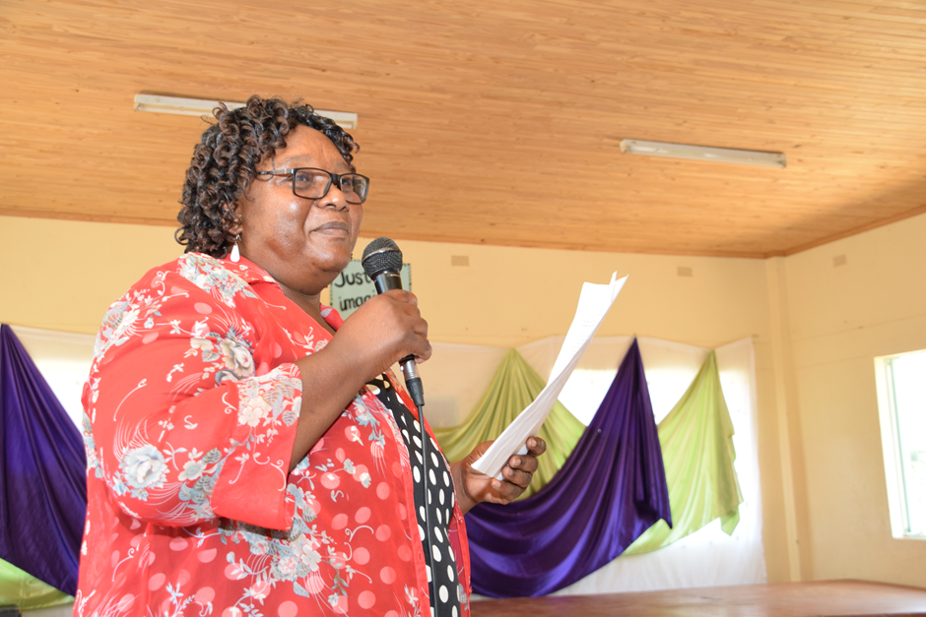
Guest of Honour (PED) represented by Mutasa District Schools Inspector Mrs C. Mlambo giving a speech during the program
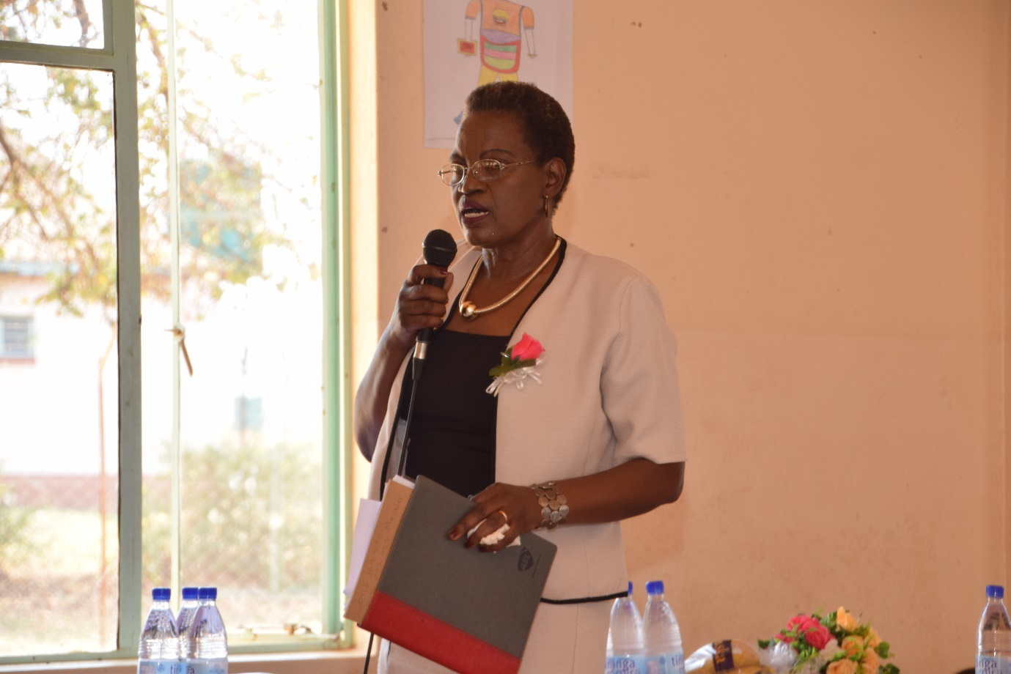
Hartzell Deputy Headmistress giving welcome remarks
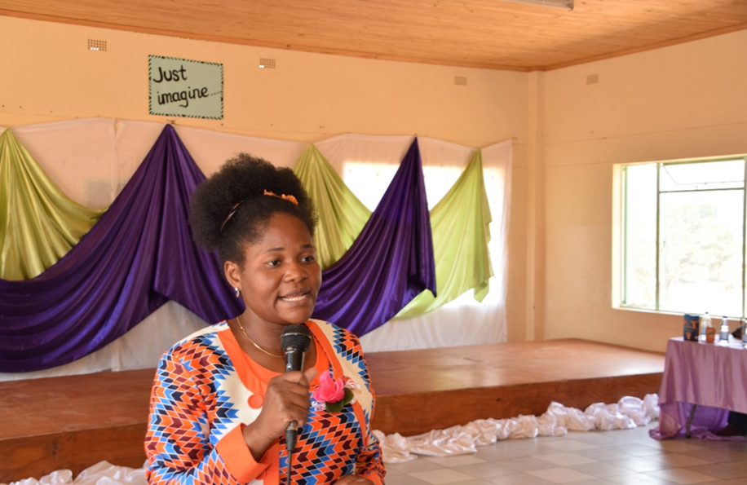
The Librarian Mrs P. Chibangwa giving a speech during the program

Testimonies on impact of school libraries
School Teacher Mrs Mudehwe- Hartzell testimonies
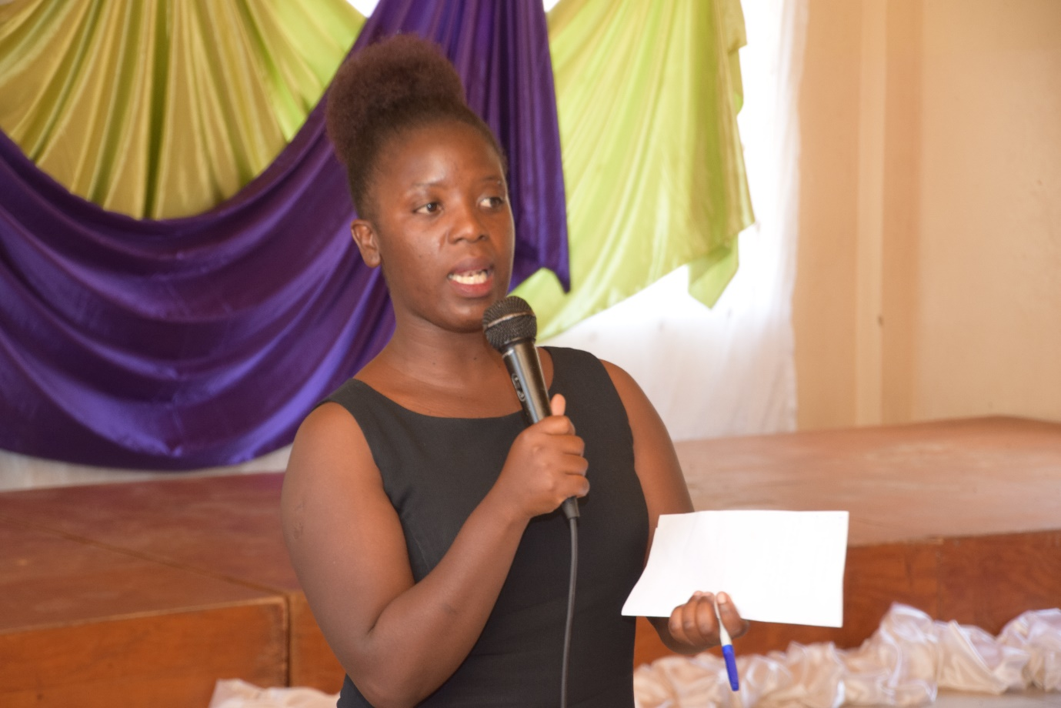
School Librarian Tinashe Kazuwazuwa- Mt. Selinda testimonies
Audiences
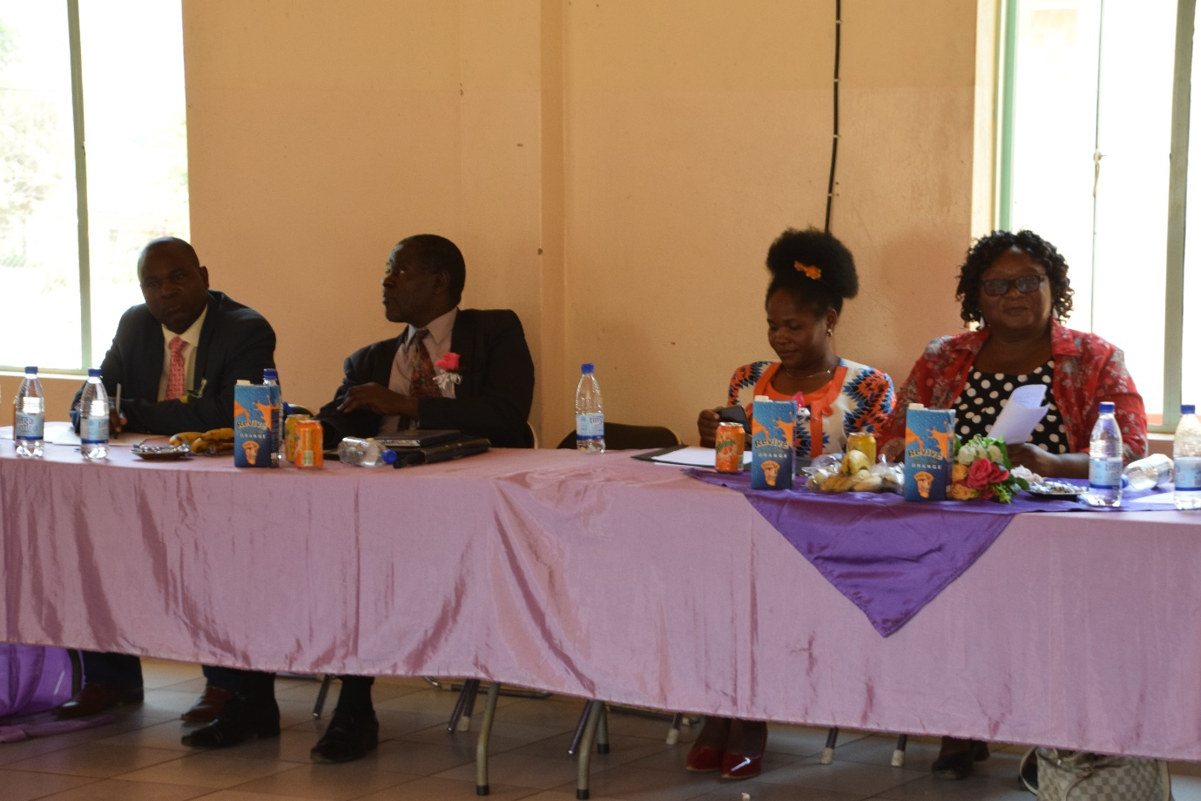
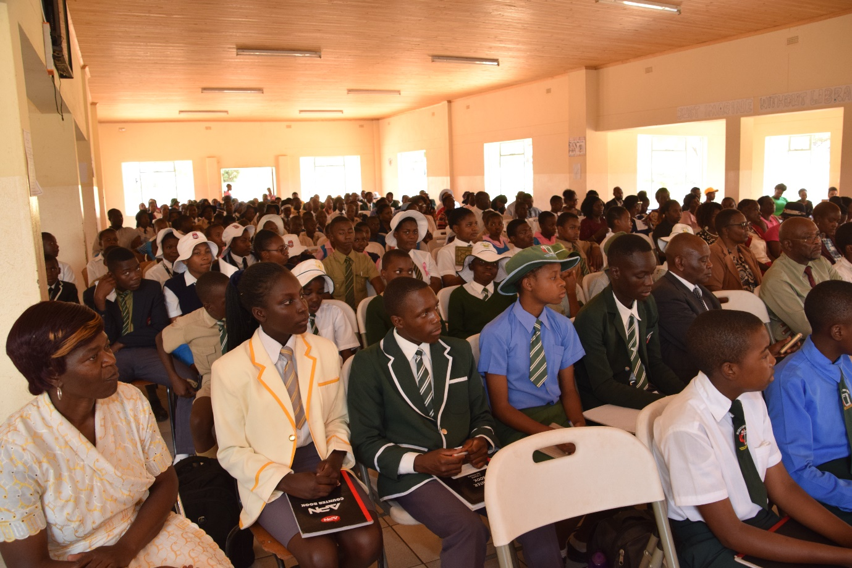

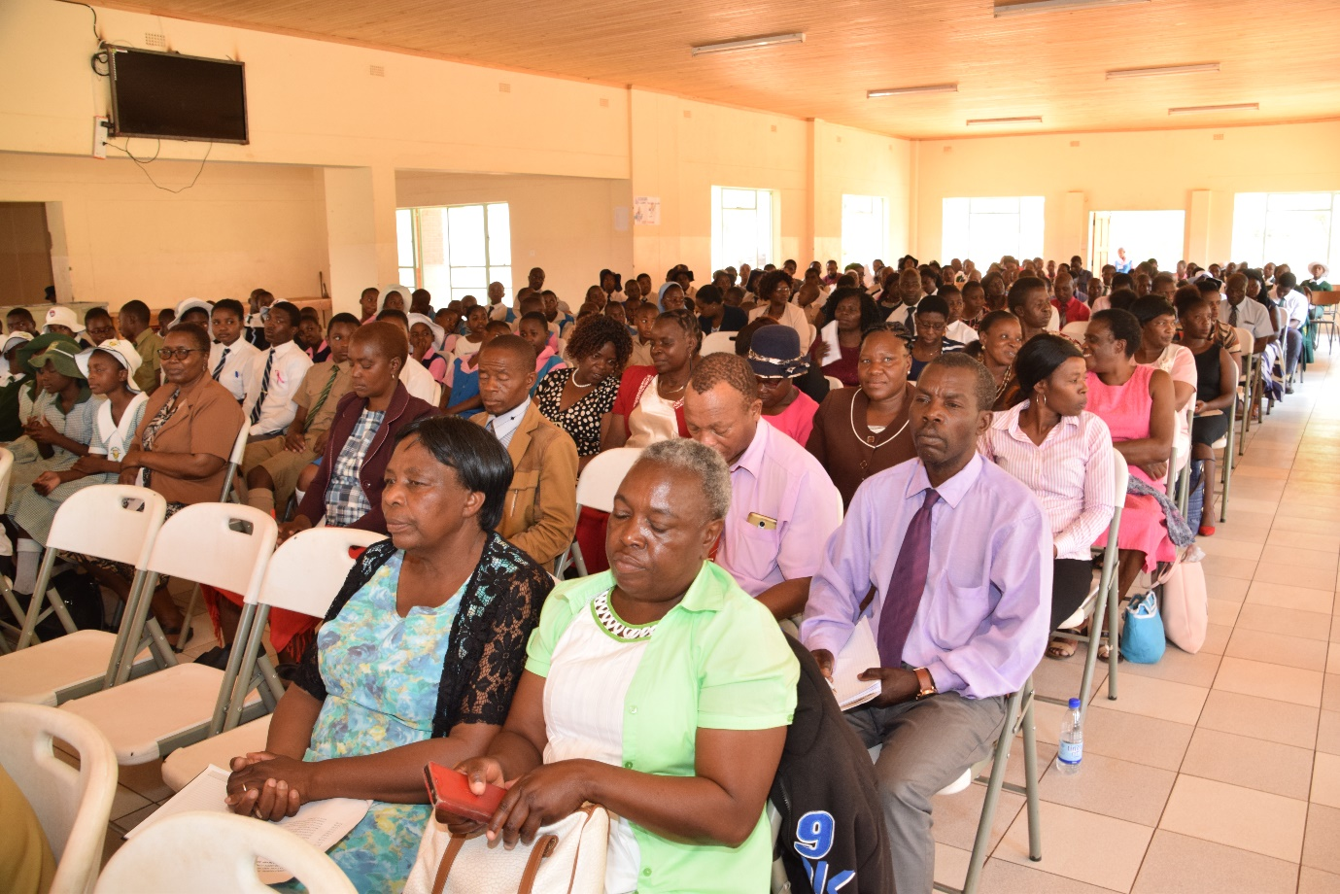
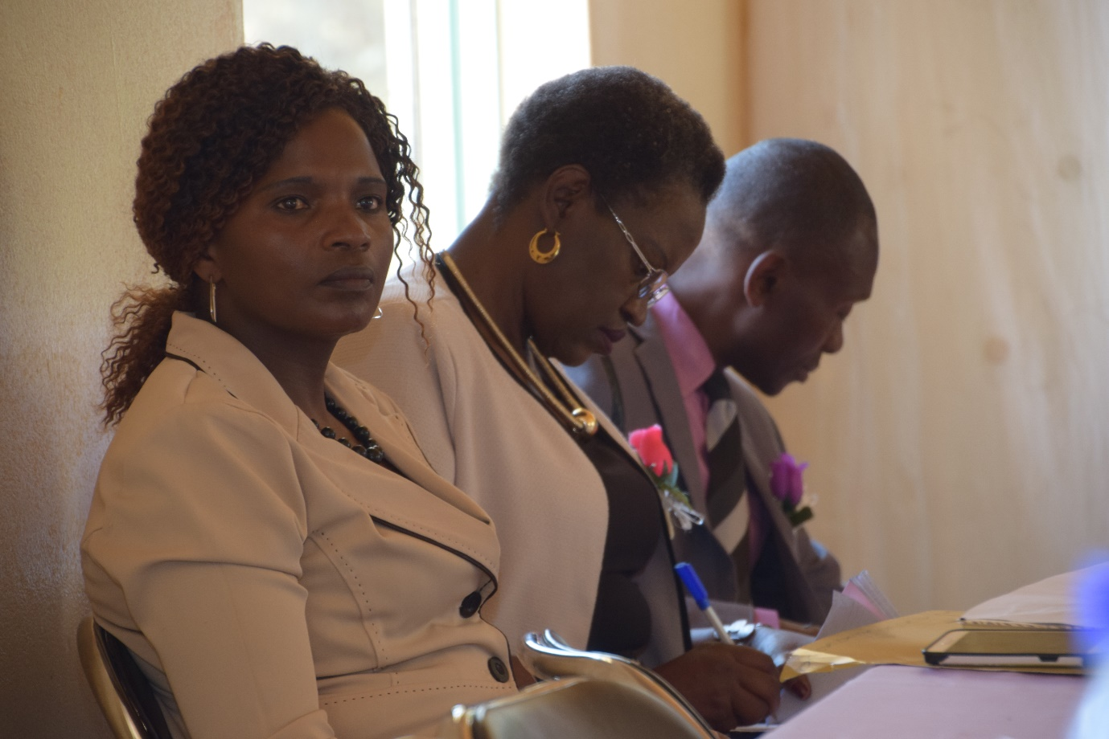
The audiences at Hartzell Primary School following the program

Student presentations
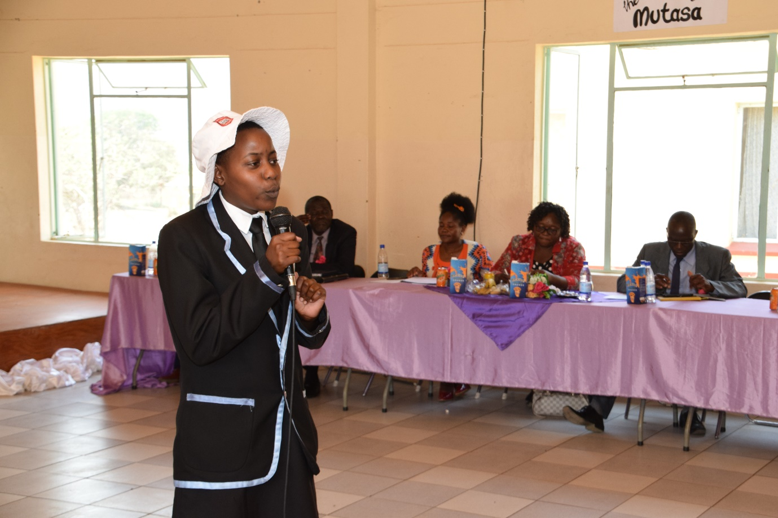
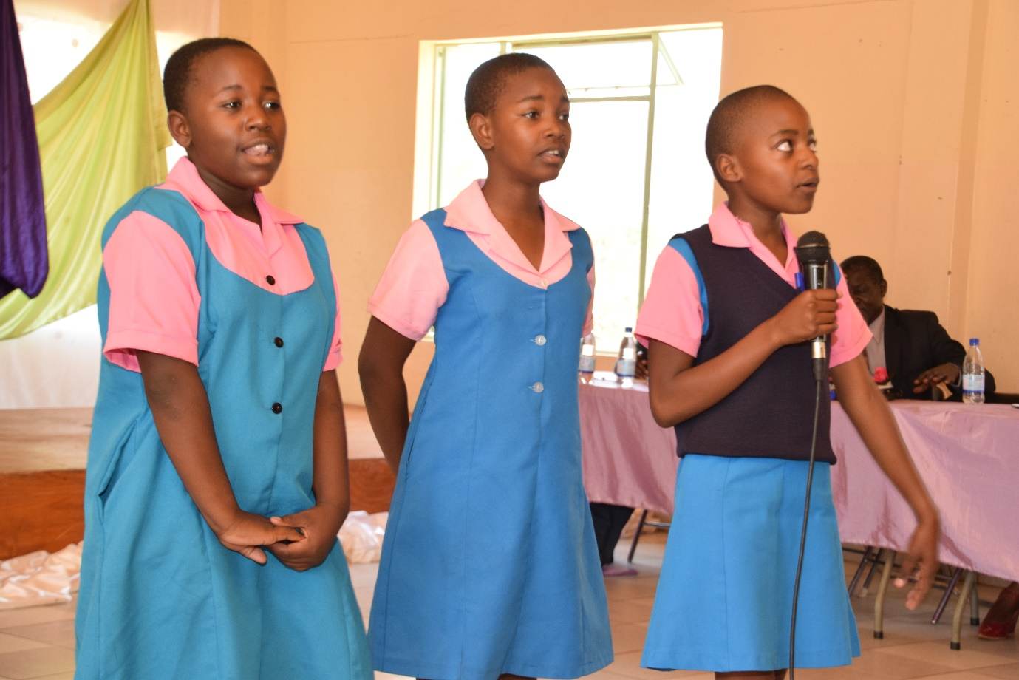
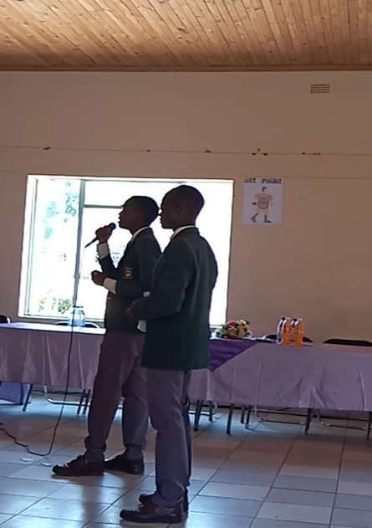

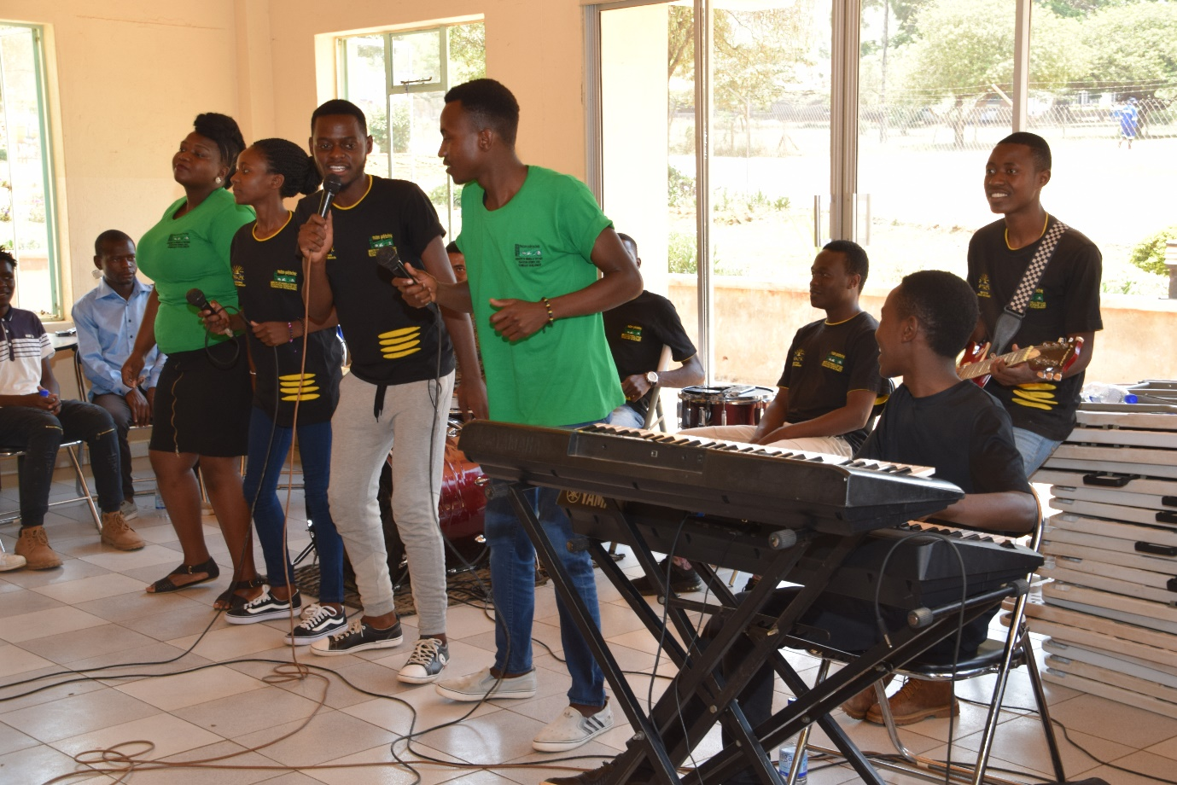
Mutare Polytechnic band entertaining participants
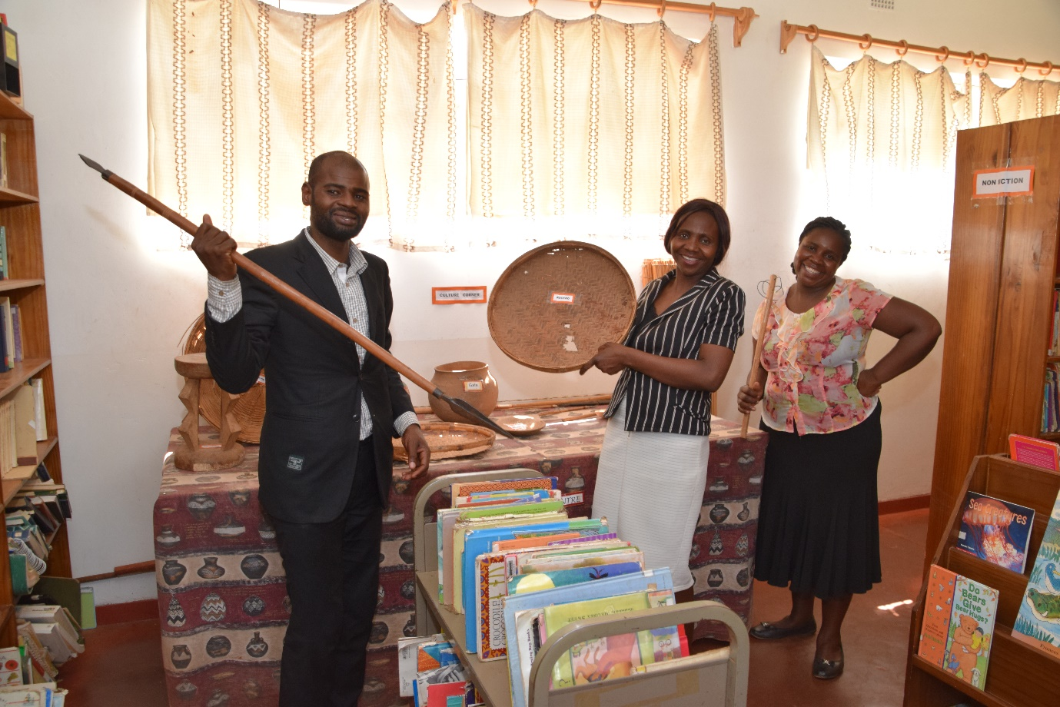
Mutare Polytechnic organising team touring Hartzell Library after the program-culture corner

