THE PSBB MILLENNIUM SCHOOL LIBRARY, COIMBATORE

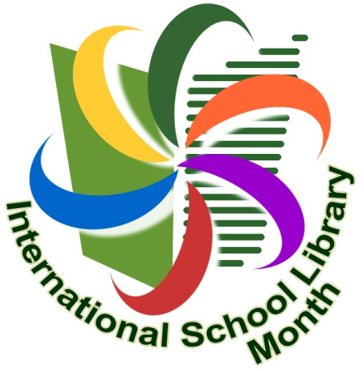
International School Library Month (ISLM)

Celebrate School Libraries every October!
International School Library Month (ISLM) is an opportunity for those in charge of school libraries around the world to choose a day, week, or the entire month in October to celebrate the importance of school libraries and to celebrate everything great about them.
The 2019 theme for ISLM is “Let’s Imagine”. It is based on the 2019 IASL conference theme of “Convergence – Empowerment – Transformation: School Libraries”. This year The students are invited to think about and celebrate the link between books, reading and school libraries and the imagination. We are inviting them to celebrate ISLM 2019 by engaging in projects and activities to explore and express this year’s theme. We hope that ISLM 2019 will be a wonderfully creative, imaginative worldwide celebration of the school library.
ACTIVITIES:-
CLASSES V & X - BOOK MARK EXCHANGE
To exchange bookmarks with USA, CROATIA, PORTUGAL and SLOVENIA ( THEME: LET’S IMAGINE )
CLASSES IV & V - COLLAGE WORK BASED ON THEIR FAVOURITE BOOK.
CLASS VI - TO CREATE ADVERTISEMENT WITH ATTRACTIVE CAPTIONS FOR THEIR SCHOOL LIBRARY.
CLASS VII - DESIGNING A NEWSPAPER FRONT PAGE REPORTING ON EVENTS/CHARACTERS IN THEIR FAVOURITE BOOK
CLASS VIII – DESIGNING A BOOK JACKET FOR THEIR OWN STORY BOOK.

