What People Are Doing for ISLM

- Country: Slovenia
- Name: Martina Batista Jenko
- Position: School librarian and history teacher
- Organization: OŠ Toneta Tomšiča Knežak

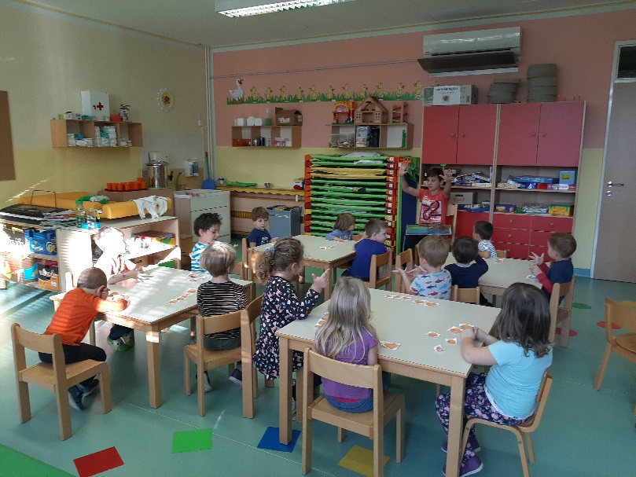
Every year we organize different activities for The International School Library Month in October. This year a lot of students are visiting school library every morning and they decided to go to the kindergarten to read childrean fairy tales. So after the snack in the school they went to the kindergarten and childrean love their reading and their presence. Also the educators in the kindergarten praised them.
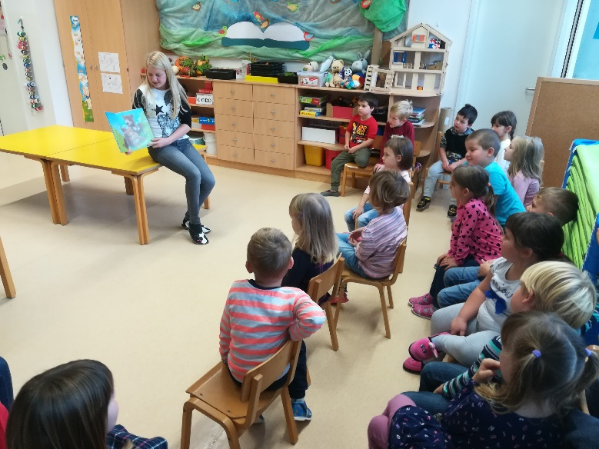
Students reading in the kindergarten.

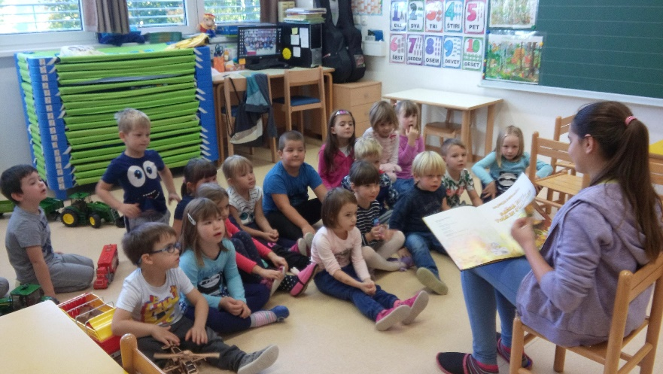

We love to participate in The Bookmark Exchange Project, this year we sent our bookmarks to Portugal to the schools- Agrupamento de Escolar de Rates and Escola Castro Matoso.

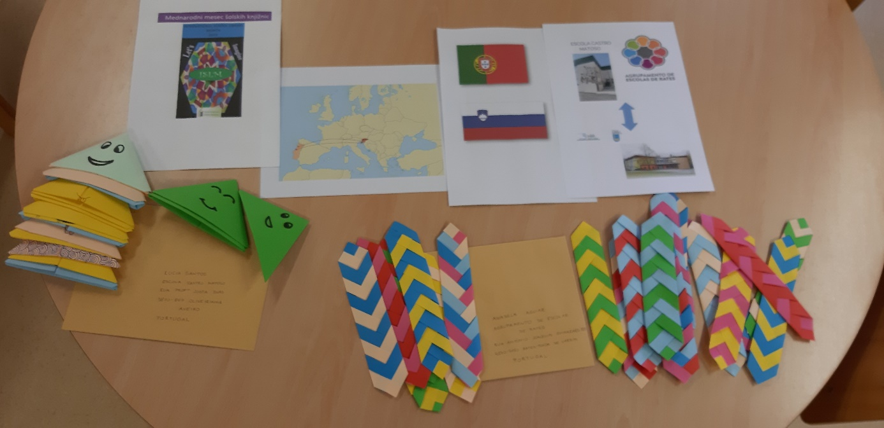
Bookmarks we sent to Portugal.
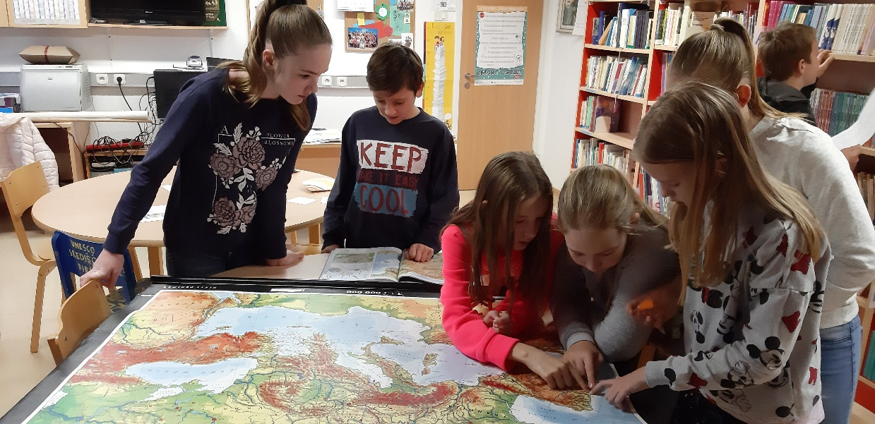
Students learning about Portugal.

In Slovenian Bookmark Exchange Project we sent our bookmarks to the OŠ Dob.
