“What People Are Doing for ISLM”

Country: Malaysia
Name : Ganga Uma a/p V. Nadarajan
Position: Teacher Librarian
Organization: SMK Tunku Abdul Rahman Putra, Kulai, Johor , Malaysia.

During the celebration of ISLM on October 2019 , our students were busy carrying out various activities , such as:
- Book mark Exchange Program with students of
Scoala Gimnaziala Toma Cocisiu Blaj in Romania
- Bookmark Exchange Program with students of
Nazarbayev Intellectual School in Kazakhstan.
- Skype Session with students of
Nazarbayev Intellectual School in Kazakhstan.
- Mind Games in the Library
- Workshop on Information Literacy for students
- Career in Librarianship: Networking with University Libraries
(Universiti Teknologi Malaysia)

Our school library during ISLM has been able to spark an interest among st students to venture into the field of librarianship. Students too eagerly came to the library to seek opportunities be it for group games, becoming more knowledgeable information seeking and getting to know new friends from faraway countries . The highlight of ISLM in the school library where we held the Skype session with fellow students from Kazakhstan. The children were excited and the exposure was memorable for all of us.

PHOTOS

A)Book mark Exchange Program with students of Scoala Gimnaziala Toma Cocisiu Blaj in Romania
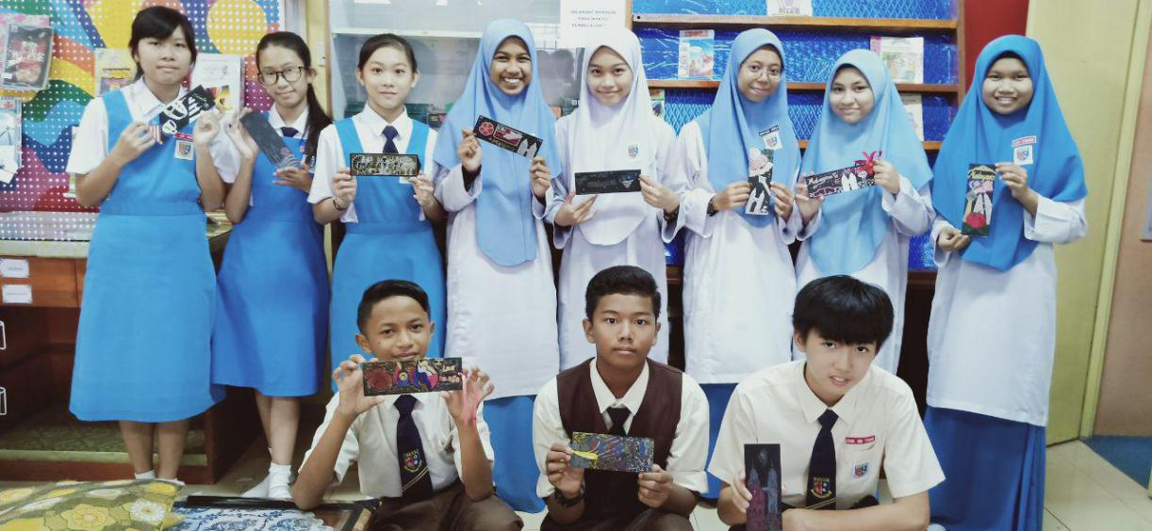
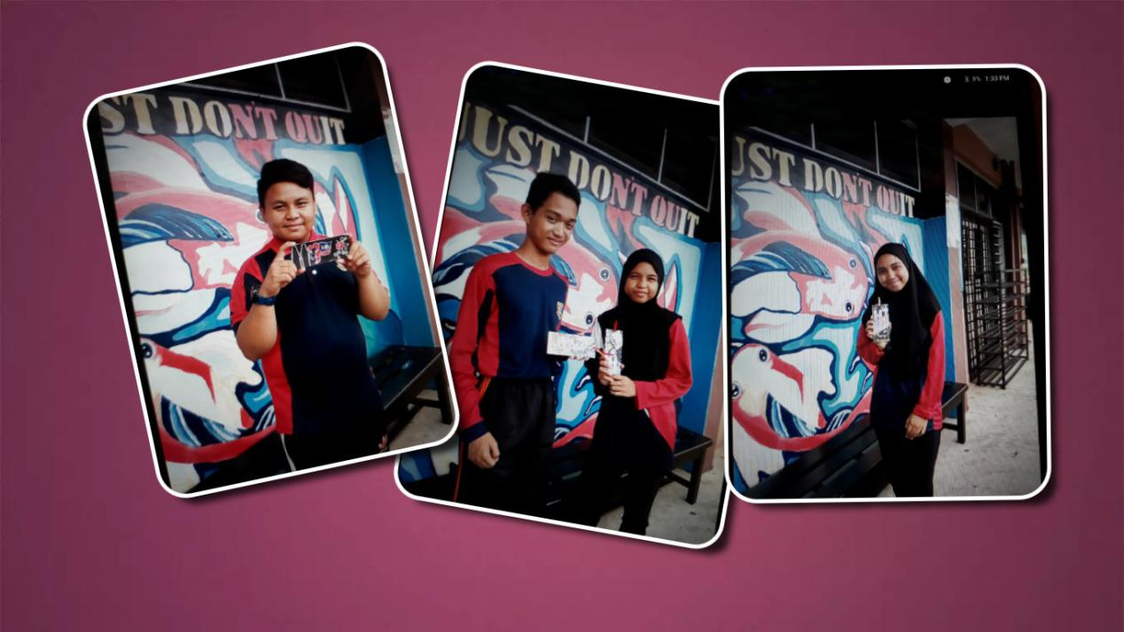

- Bookmark Exchange Program with students of Nazarbayev Intellectual School in
Kazakhstan
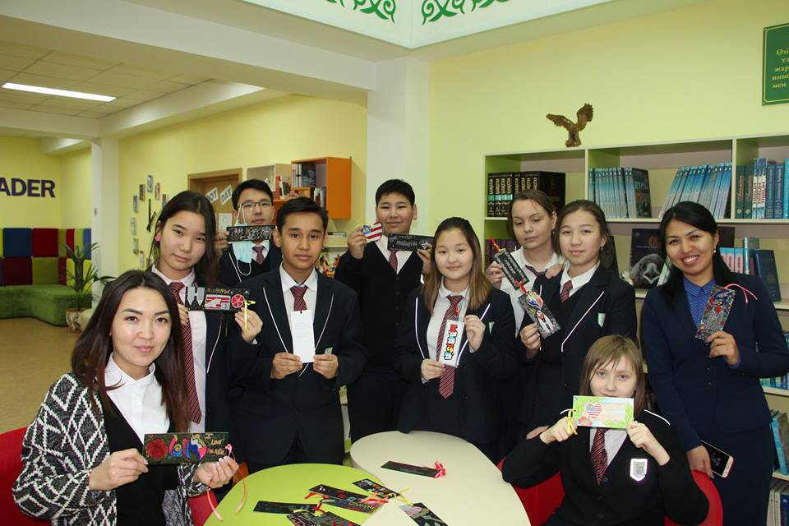
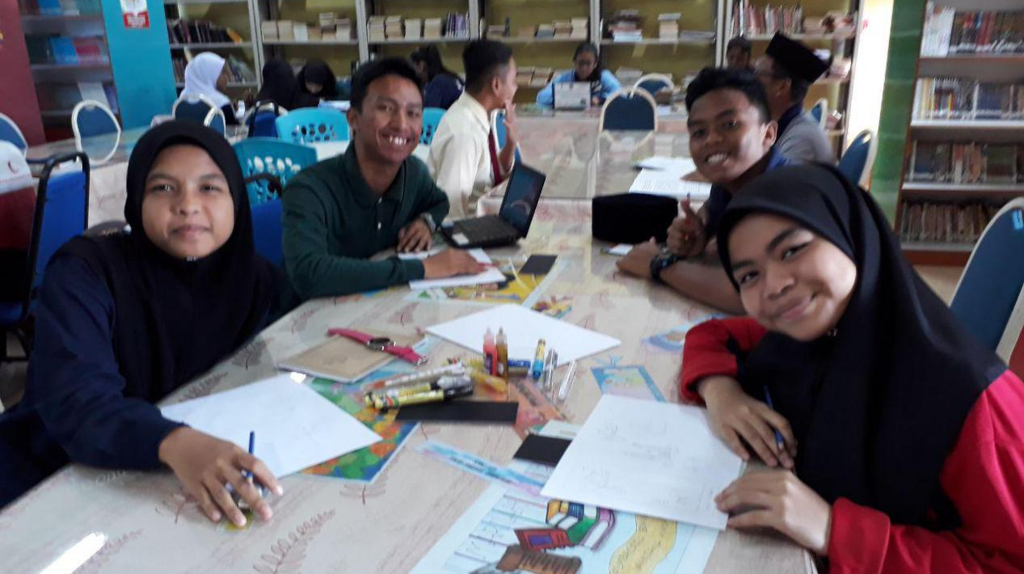

- Skype Session with students of Nazarbayev Intellectual School in Kazakhstan.
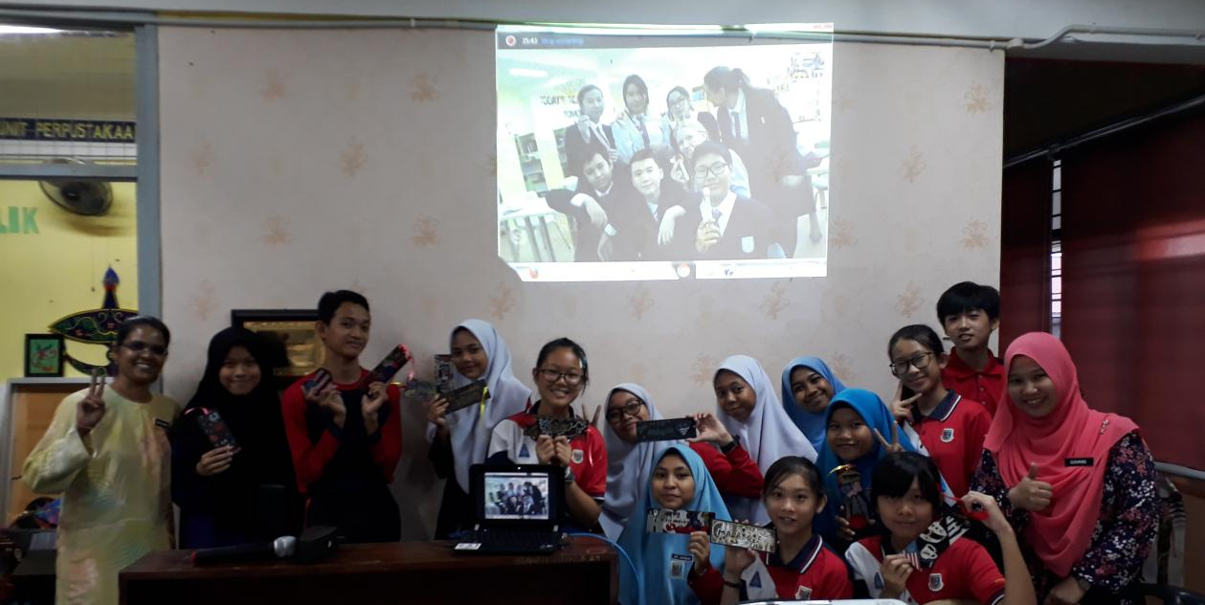
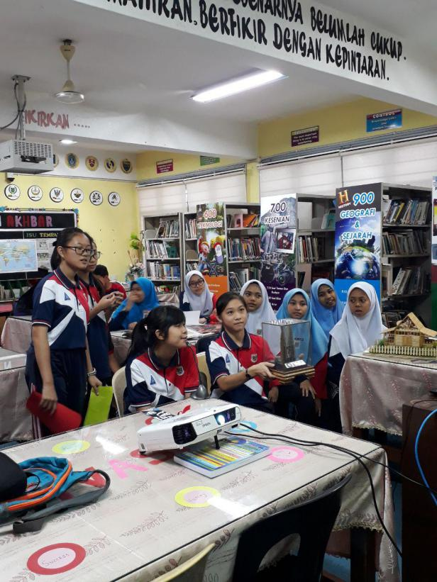 | 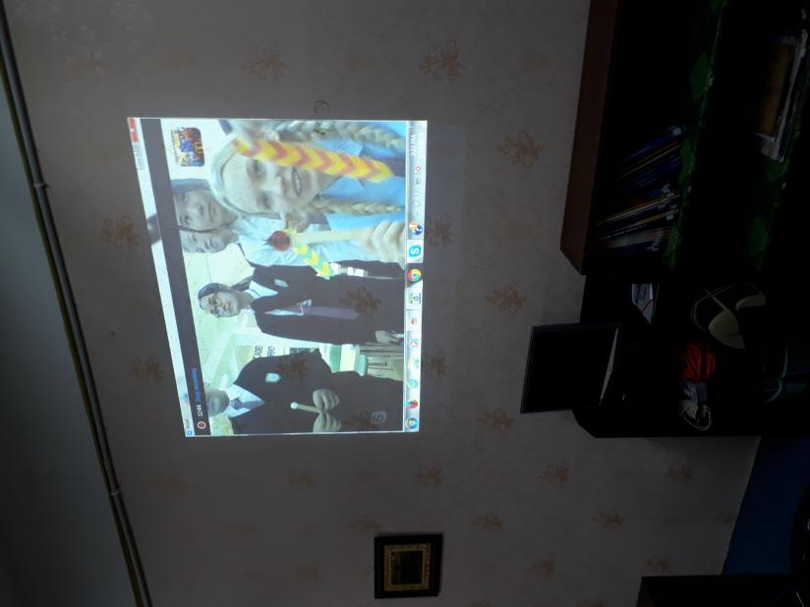

D)Mind Games in the Library
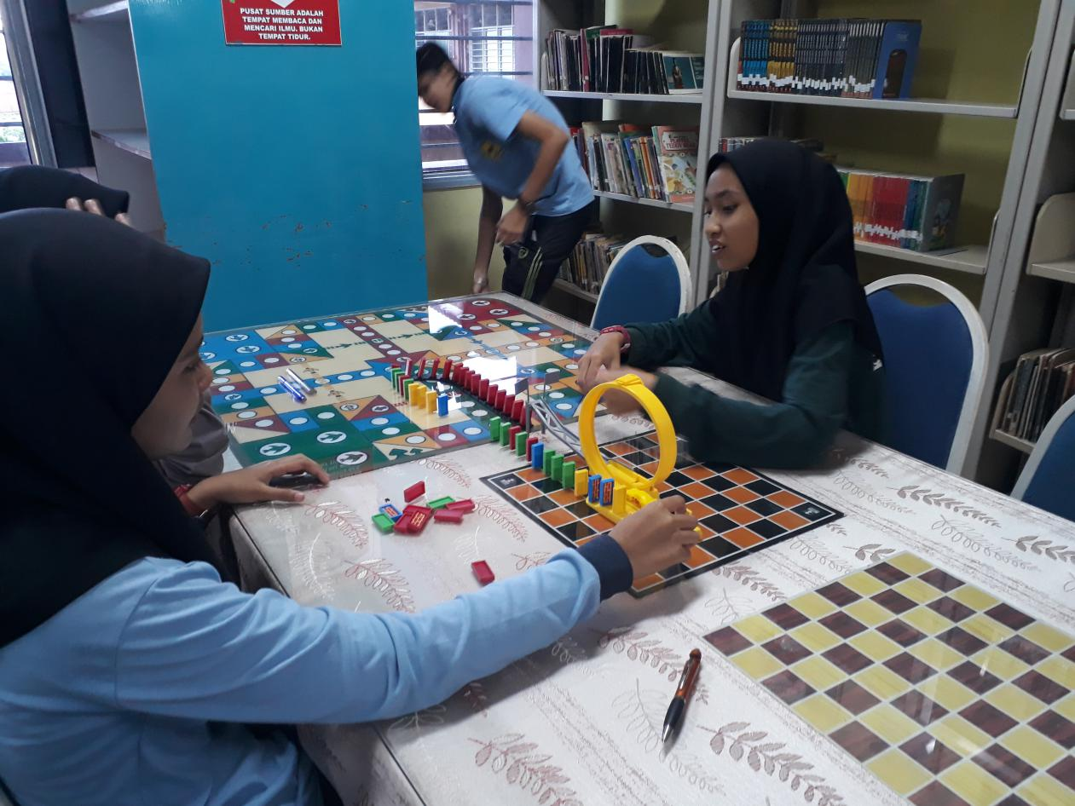
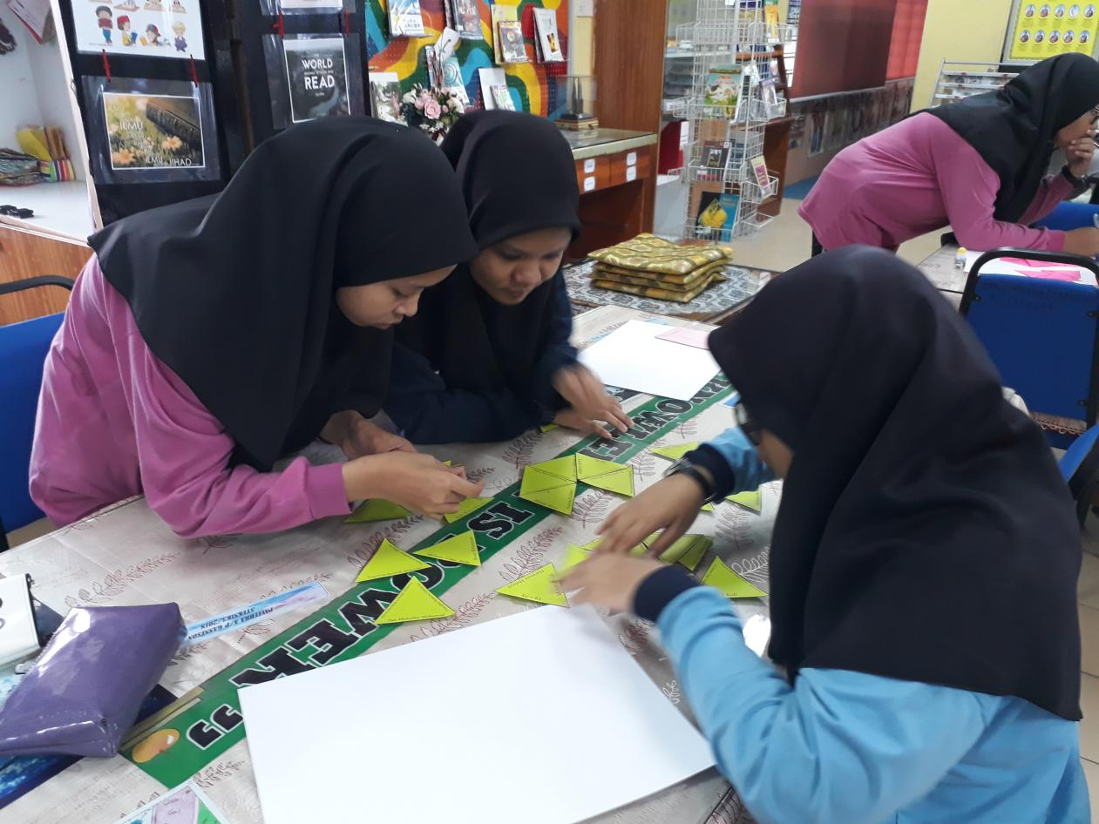

E) Workshop on Information Literacy for students
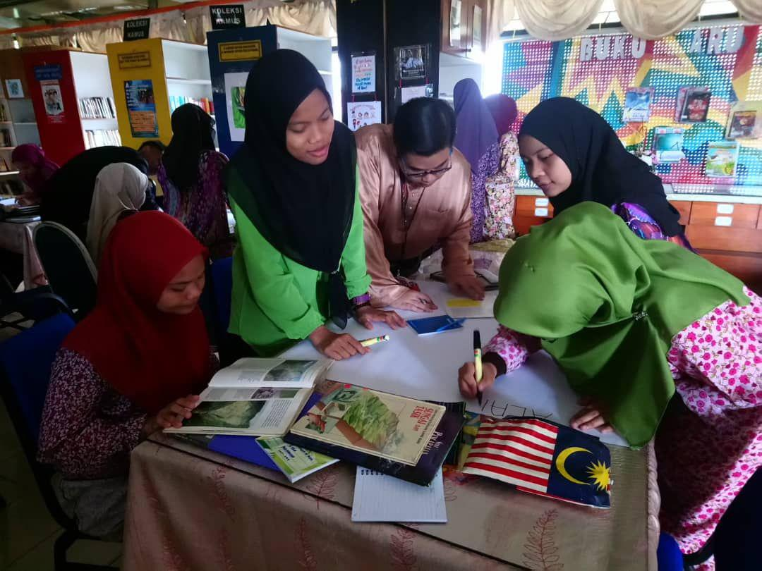
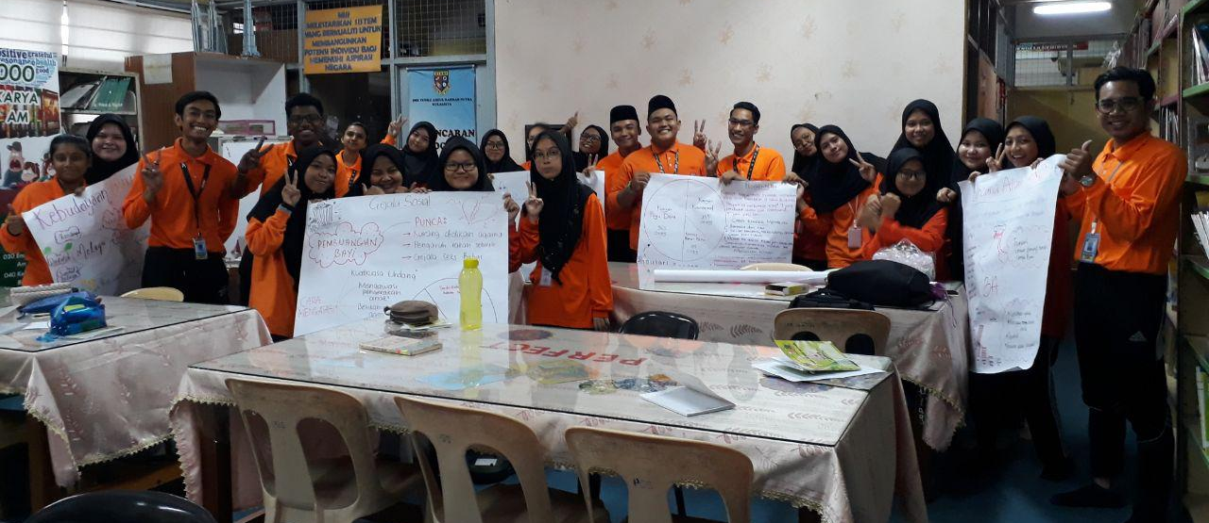

- Career in Librarianship: Networking with University Libraries
