DELHI PUBLIC SCHOOL, VASANT KUNJ
INTERNATIONAL SCHOOL LIBRARY MONTH
OCTOBER 2018

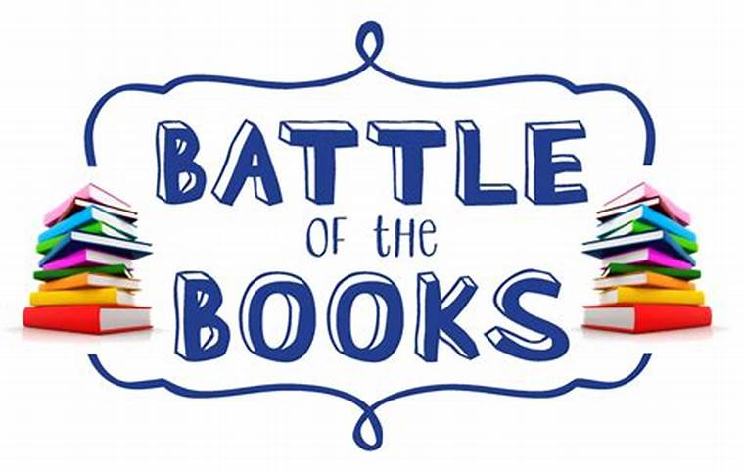
Country: India
Name: Sigy George (Sr. Librarian)
Organization: Delhi Public School, Vasant Kunj, New Delhi(India)

" BATTLE OF THE BOOKS"
" There's no such thing as a kid who hates reading. There are kids who are reading the wrong books." ------James Patterson.

The month of October is celebrated as the International School Library Month worldwide. Several activities and programs are organised in school libraries all over the world to promote reading and develop a love for books. Imbibing the spirit and the theme this year, we at Delhi Public School decided to give a flavour to the celebration.

The Senior Library organised a "Battle of Books", wherein students of classes X-XII, were engaged in a variety of quizzes and puzzles based on their favourite books. Four books namely, Harry Potter, Hunger Games, Percy Jackson and Game of Thrones were chosen for the same. The intention of the battle was to determine the most popular book among the students and to see how much they know about it. The students were highly enthusiastic about the event and there was whole hearted participation from the students. Some avid readers attempted quizzes on all four books. The library was buzzing with excitement and thrill. There were challenges among the fans to show their support and knowledge for their favourite book.

Quizzes, Crosswords and Word search were designed on each book to assess the knowledge and familiarity with the book. The students were thoroughly surprised when they sometimes fell short of getting correct answers even as they prided themselves as being the biggest fans. The students loved the energy and enthusiasm that surrounded the library. Thus the theme for this year: " Why I Love My School Library" was satisfied as students reiterated that they love their school library as its their route to a land where they can be anyone and can possess the power to their world.

Ms. Sigy George
(Sr. Librarian)

